**Summarization of placement Dataset:**

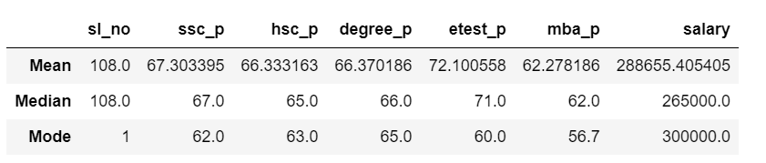

**Mean:**

Mean is often called the average. Useful for understanding the general trend of a dataset, but it can be influenced by outliers.

**Median:**

The **median** is the middle value in a dataset when the numbers are arranged in order (either ascending or descending) and is especially useful because it’s not affected by extreme values (outliers) as much as the mean.

**Mode:**

The **mode** is the value that appears most frequently in a dataset that shows the most common values in the data. Unlike the mean and median, a dataset can have more than one mode or no mode at all.

In this table, the average scores for ssc_p, hsc_p, and degree_p are all close, around 65-67%, showing that students generally performed similarly in these areas. However, in etest_p, the average score is higher at 71%, meaning students tended to do better on this test.

The average salary (mean) is quite high at about 288,655, but this number may be affected by a few students who got very high salaries, making it seem like everyone earned more than they actually did (outliers). The most common salary (mode) is 300,000, which suggests that many students received this amount.